# Covid Customer Data Storage for Simphony

## Overview

Bars and Restaurants have been closed for many months due to Covid-19.

On the 4th July the UK government will allow Bars and Restaurants to reopen. One of the conditions of reopening is that all customers contact details must be stored for 21 days. In the event of an outbreak this customer data can be used to notify the customers that they may have been in contact with an infected person.

I have created this simple extension application which will help record the customer data securely and make it easy to export the data to a .CSV (Comma Separated Value) File should the list of customers be required.

The customer data recorded is the:

* Customer Name
* Customer Phone Number
* Date & Time the data entry was made

## Functionality

1. Two buttons will be required to be configured on the Page Designer.
   1. Button 1 will allow the user to enter the customer Data which is stored in an AES-256 password encrypted archive.
   2. Button 2 will allow an authorised user who has the encryption key to export the customer records to a plain text CSV file.
   3. The customer data will be stored independently on each Simphony workstation and will need to be manually retrieved and copied elsewhere. Eg. A USB stick.
2. The customer data archives will be automatically purged 21 days after they are created.

## Supported Versions

This Simphony extension application has been developed and tested to work on Simphony 18.2 on Windows, however it should work on earlier versions too.

## License

The Extension Application DLL & Code are offered free of charge. I offer no guarantee of support or that it will be updated should the UK government change the COVID guidelines.

You use this extension application at your own risk.

Full code is available using the below Github link.

<https://github.com/cathalmf/SimphonyExtensibility/tree/master/CovidCustomerData>

## Installation Prerequisites

You must have access to the Simphony EMC.

It is recommended you understand the Simphony EMC and have experience configuring Extension Applications.

## Installation

1. Sign into the Simphony EMC
2. At the Enterprise level select the Configuration tab and choose Data Extensions

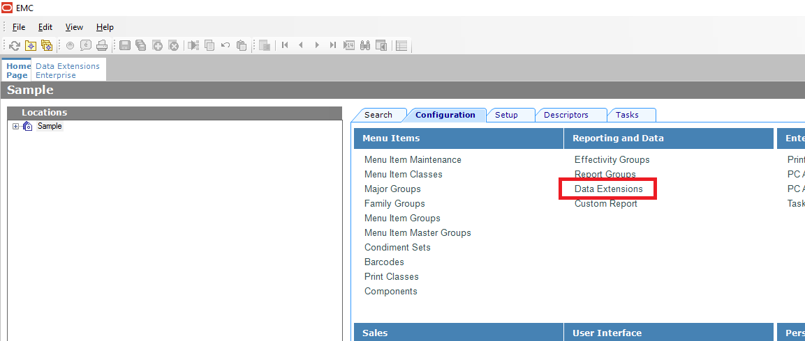

1. Add a new Data Extension
   1. Table: 1001 – Property
   2. Extra Column Name: EncryptionKey
   3. Type: 0 – Text

Please note that the Extra Column Name field is Case Sensitive. Enter it exactly as shown above with no spaces before or after.

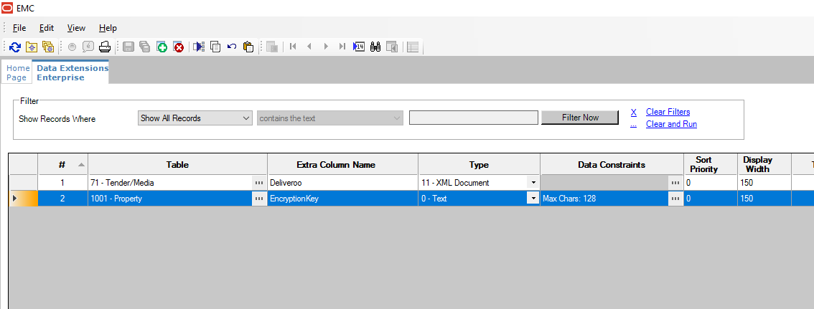

1. Save and Close the Data Extensions tab.
2. At the Enterprise level select the Setup tab and choose Properties.

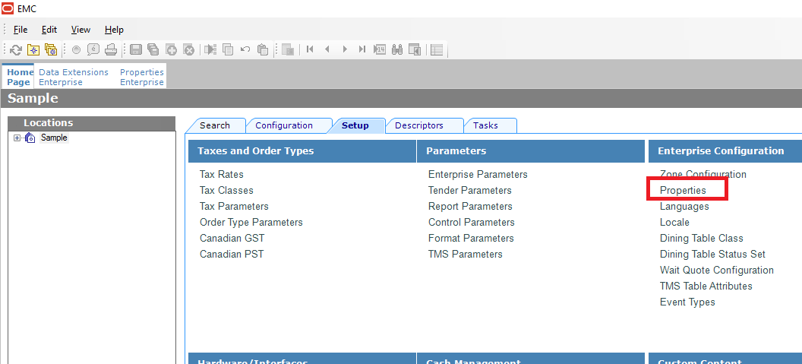

1. Select the Property you want to enable this Extension Application to work on and select the Data Extensions tab.
2. You will see an EncryptionKey value in the list with a text box on the right side. You should enter an Encryption Key that you decide on. This is a password that will be used to protect the customer data. This is a password that you will need if you want to export the customer data to read it later. You should only share this password to those who need to export it.

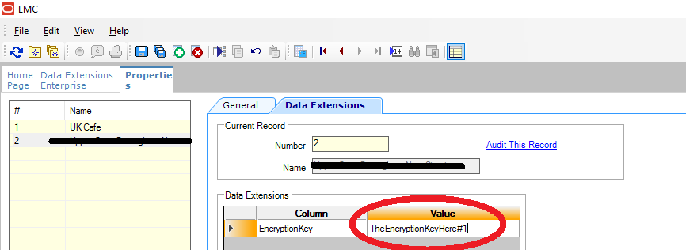

1. Repeat steps 6 & 7 for any properties you want to configure.
2. Save and Exit the Properties tab.
3. At the Enterprise level choose the Setup tab and select “Extension Application”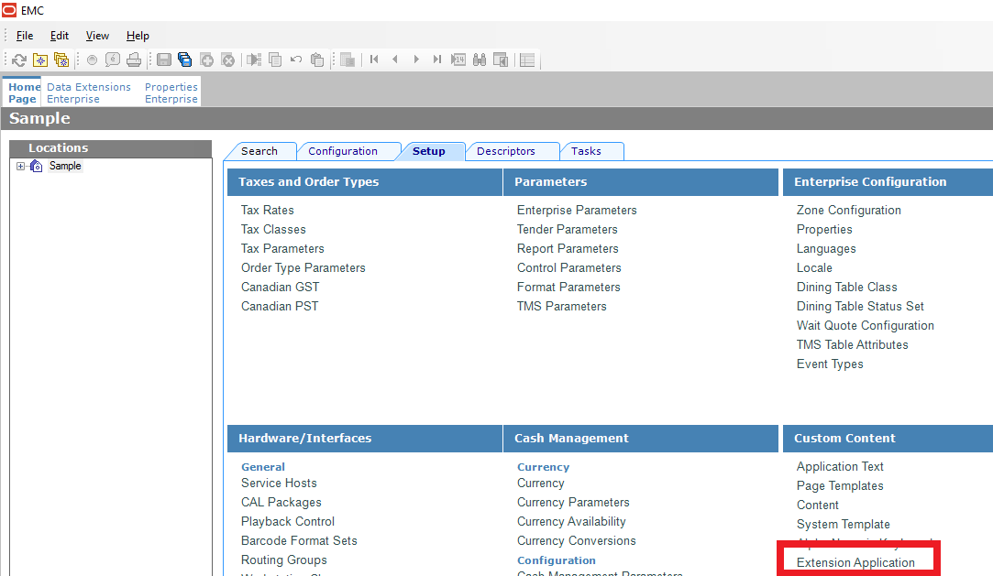
4. Insert a new Record and call it “Covid Customer Data” and press OK

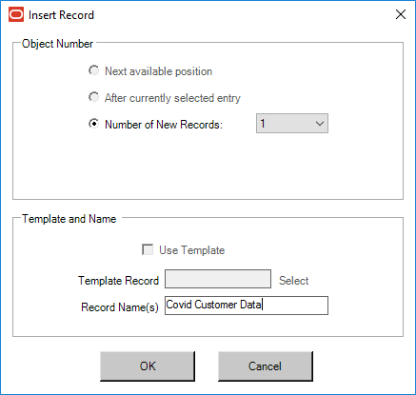

1. Select this record by double clicking on it or select the “Toggle Table/Form view” in the toolbar.
2. Choose “Insert Application Content”

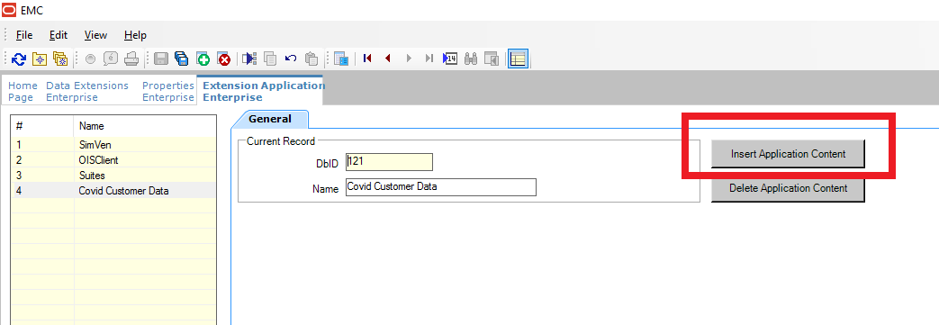

1. Enter the following details and press OK:
   1. Zoneable Key: Application
   2. Description: Extension Application

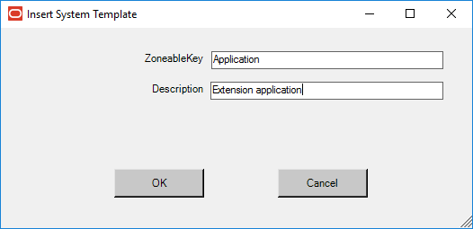

1. Change the Content Type dropdown to “3 - DLL”
2. Select the “Import from a file” link and select the “CovidCustomerData.dll” file.
3. Select the General Tab and select “Insert Application Content” again.
4. Enter the following details and press OK:
   1. DotNetZip
   2. DotNetZip Library

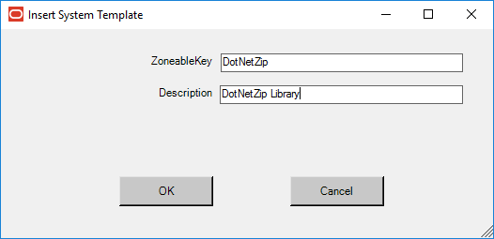

1. Change the Content Type dropdown to “3 - DLL”
2. Select the “Import from a file” link and select the “DotNetZip.dll” file.
3. Select the General Tab
4. Scroll across to the “Disk File Name” column.
5. For the Application record set the Disk File Name to CovidCustomerData.dll
6. For the DotNetZip record set the Disk File Name to DotNetZip.dll
7. Save the changes and close the Extension Application tab.

## Page Design configuration

We need to configure two buttons on the touchscreen to use the functionality of this Extension Application.

The “Save Customer Data” button is responsible for prompting the user to enter the customers name and phone number and saving the data to an encrypted file on the workstations hard drive.

The “Export Records To CSV” button is responsible for decrypting the data entries and merging all the data entries together and exporting them to a CSV file which can be used to contact each customer in the case where this is necessary.

1. Select an appropriate page in the Page Designer and add two new buttons and configure them with the below settings:

**Save Customer Data Button**

Legend: Save Customer Data

Type: Function – Run Extensibility App

Arguments: ;type=dll;appname=Covid Customer Data;filename=CovidCustomerData.dll;function=SaveCustomerData

**ExportRecordsToCSV Button**

Legend: Export Records To CSV

Type: Function – Run Extensibility App

Arguments: ;type=dll;appname=Covid Customer Data;filename=CovidCustomerData.dll;function=ExportRecordsToCSV

1. Save the changes and close the Page Designer.

The changes will automatically download to your workstations however if you want to force the download then reload the database on the workstation and restart the workstation.

See the User Guide section for how the application works.

## User Guide

**Save Customer Data Button**

When a staff member presses this button they will be prompted to enter the customers name and phone number. See the below screenshots of how this will look.

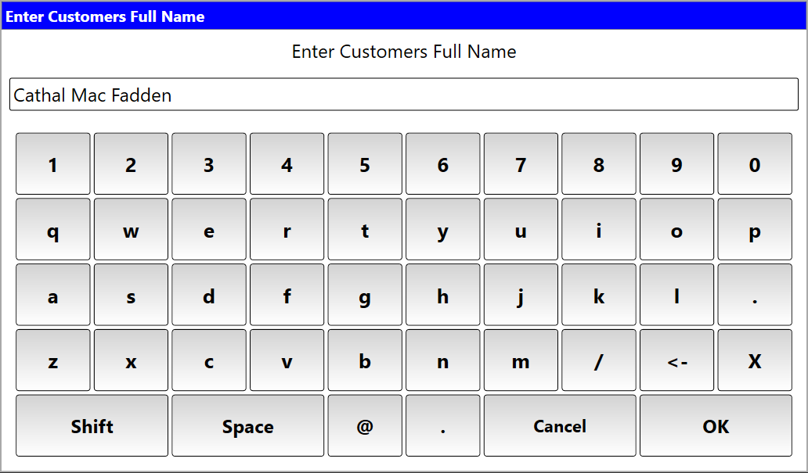

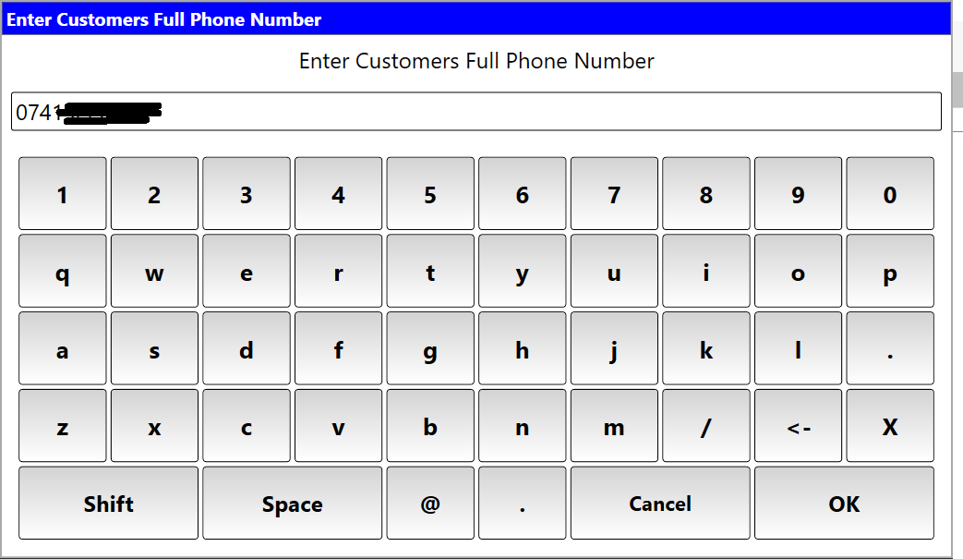

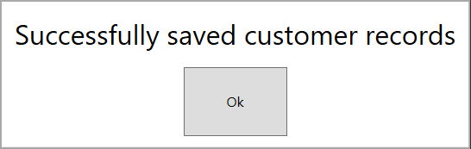

The customer record will be saved to encrypted ZIP files in C:\Micros\Simphony\WebServer\wwwroot\EGateway\Handlers\ExtensionApplications\Covid Customer Data\CovidCustomerDataFiles

**Export Records To CSV Button**

When staff press this button they will be prompted to enter the Encryption Key configured in the EMC. They must enter the correct Encryption Key before they can export the data to CSV.

See the below screenshots for how it looks.

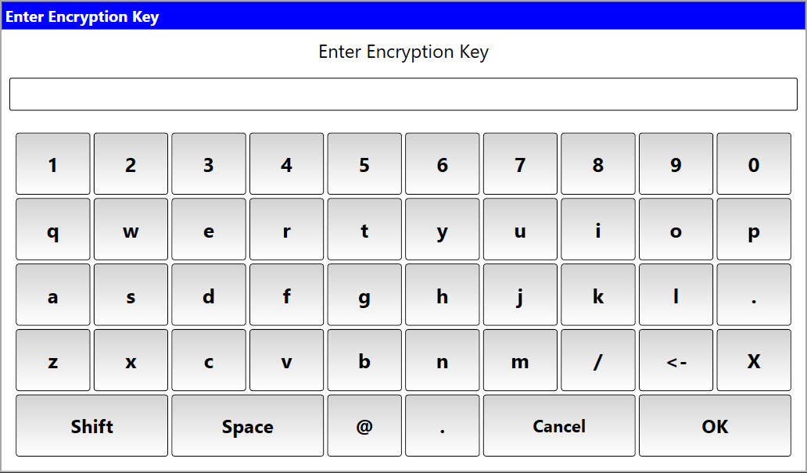

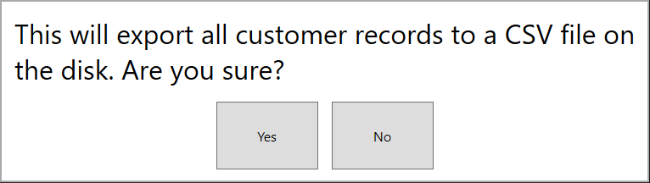

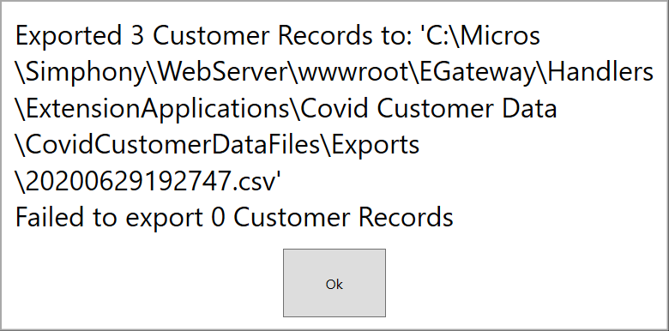

The final message box tells you where the CSV file has been saved to.

It is always stored in C:\Micros\Simphony\WebServer\wwwroot\EGateway\Handlers\ExtensionApplications\Covid Customer Data\CovidCustomerDataFiles\Exports